**Assignment 5 - Wireshark Lab: UDP v6.1**

**Packet trace taken from author**

**Answer 1:** 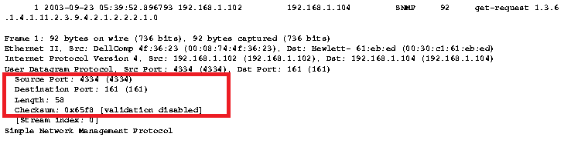

* The number of fields in the UDP Header is 4. They are –
* Source Port
* Destination Port
* Length
* Checksum

**Answer 2:**

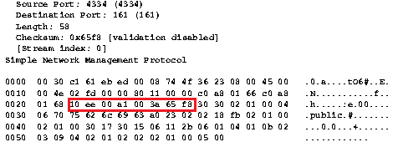

|  |  |  |  |
| --- | --- | --- | --- |
| Hex | Decimal | Field | Size |
| 10 ee | 4334 | Source Port | 2 Bytes |
| 00 a1 | 161 | Destination Port | 2 Bytes |
| 00 3a | 58 | Length | 2 Bytes |
| 65 f8 | Not required | Checksum | 2 Bytes |

* Size of each of the UDP Header fields is 2 Bytes.
* Also it means UDP header can have maximum of 2 * 4(fields) =8 Bytes size.

**Answer 3:**

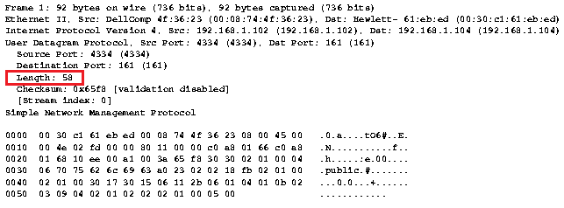

* The value in the Length Field is = 58 and it’s the Size of UDP that includes Header and data. Since we know from 2nd answer that header fields are only 8 bytes so this value can only represent the size of the entire packet including header.

**Answer 4:**

* The maximum size that can be included in the UDP payload depends on the maximum value the 16bit integer field (**= Length**) can hold. The maximum value of 2^16 -1 (=**65535**).
  + Header = 2 Bytes * 4(fields) = 8 Bytes
  + Total = 65535 Bytes
  + Pay Load Size = Total – header = 65535 – 8 = **65527**

**Answer 5:**

* The largest possible source port number is again the maximum value of 2^16 – 1 (=**65535**)

**Answer 6:**

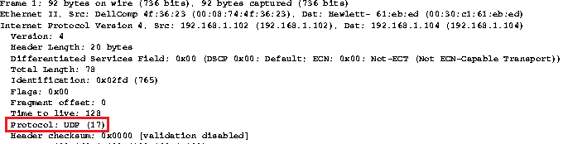

* The protocol number of UDP is **17 in decimal and 0x11 in hex.**

**Answer 7:**

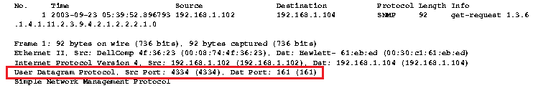

**First Packet**

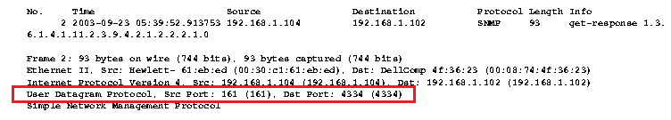

**Second Packet**

* The first packet is a UDP packet sent from Source Address : - **192.168.1.102** to Destination Address :- **192.168.1.104**
* The second packet is a UDP response packet from Source Address : - **192.168.1.104** to Destination Address :- **192.168.1.102**
* The port numbers in the two packets indicate that there is a transfer of messages using UDP Protocol between two applications using SNMP Application layer protocol in the same network.
* One application at **192.168.1.102** is listening at **port 4334** and other application at **192.168.1.104** is listening at **port 161**